Project Planning Phase
Project Planning Template (Product Backlog, Sprint Planning, Stories, Story points)

Date | 17 February 2026
Team ID | LTVIP2026TMIDS78778
Project Name | Gemini Historical Artifact Description System
Maximum Marks | 5 Marks

Product Backlog & Sprint Schedule (4 Marks)
Sprint | Functional Requirement (Epic) |  | User Story No |  | User Story / Task |  |  | Story Points | Priority |  | Team Members
Sprint-1 | Registration |  | USN-1 |  | As a user, I can register using email and password |  |  | 2 | High |  | Rajakumar varshitha
Sprint-1 | Registration |  | USN-2 |  | As a user, I receive confirmation email after registration |  |  | 1 | High |  | Rajakumar varshitha
Sprint-1 | Registration |  | USN-4 |  | As a user, I can register using Gmail |  |  | 2 | Medium |  | Rajakumar varshitha
Sprint-1 | Login |  | USN-5 |  | As a user, I can login using email & password |  |  | 1 | High |  | Rajakumar varshitha
Sprint-1 | Role Management |  | USN-6 |  | Admin can create roles (Admin, Agent, User) |  |  | 3 | High |  | Rajakumar varshitha
Sprint-1 | Dashboard |  | USN-7 |  | Role-based dashboard redirection |  |  | 3 | High |  | Rajakumar varshitha
Sprint |  | Functional Requirement (Epic) |  | User Story No |  | User Story / Task | Story Points |  |  | Priority |  | Team Members
Sprint-2 |  | Agent Management |  | USN-8 |  | Admin can add new agents | 3 |  |  | High |  | Rajakumar varshitha
Sprint-2 |  | Agent Management |  | USN-9 |  | Admin can update/delete agents | 3 |  |  | High |  | Rajakumar varshitha
Sprint-2 |  | User Management |  | USN-10 |  | Admin can view user list | 2 |  |  | Medium |  | Rajakumar varshitha
Sprint-2 |  | Assignment |  | USN-11 |  | Admin can assign agent to user | 3 |  |  | High |  | Rajakumar varshitha
Sprint-2 |  | Social Login |  | USN-3 |  | User can register using Facebook | 2 |  |  | Low |  | Rajakumar varshitha

Sprint |  | Functional Requirement (Epic) |  | User Story No |  | User Story / Task | Story Points |  | Priority |  | Team Members
Sprint-3 |  | Ticket Management |  | USN-12 |  | User can create ticket | 3 |  | High |  | Rajakumar varshitha
Sprint-3 |  | Ticket Management |  | USN-13 |  | User can view ticket status | 2 |  | High |  | Rajakumar varshitha
Sprint-3 |  | Ticket Management |  | USN-14 |  | Agent can update ticket status | 3 |  | High |  | Rajakumar varshitha
Sprint-3 |  | Ticket Management |  | USN-15 |  | Agent can view assigned users | 2 |  | High |  | Rajakumar varshitha
Sprint | Functional Requirement (Epic) |  | User Story No |  | User Story / Task |  |  | Story Points |  | Priority |  | Team Members
Sprint-4 | Reports |  | USN-16 |  | Admin can view system reports |  |  | 3 |  | Medium |  | Rajakumar varshitha
Sprint-4 | Notifications |  | USN-17 |  | Email notification for ticket updates |  |  | 3 |  | Medium |  | Rajakumar varshitha
Sprint-4 | Security |  | USN-18 |  | Password reset functionality |  |  | 2 |  | High |  | Rajakumar varshitha
Sprint-4 | UI Enhancement |  | USN-19 |  | Improve dashboard UI |  |  | 2 |  | Low |  | Rajakumar varshitha

Project Tracker, Velocity & Burndown (4 Marks)
Sprint | Total Story Points | Duration | Sprint Start Date | Sprint End Date (Planned) | Story Points Completed | Sprint Release Date (Actual)
Sprint-1 | 20 | 6 Days | 10 Feb 2026 | 15 Feb 2026 | 20 | 15 Feb 2026
Sprint-2 | 20 | 6 Days | 17 Feb 2026 | 22 Feb 2026 | 18 | 22 Feb 2026
Sprint-3 | 20 | 6 Days | 24 Feb 2026 | 01 Mar 2026 | 20 | 01 Mar 2026
Sprint-4 | 20 | 6 Days | 03 Mar 2026 | 08 Mar 2026 | 19 | 08 Mar 2026

Velocity Calculation
Given:
- Sprint Duration = 10 Days
- Team Velocity = 20 Story Points per Sprint
Average Velocity (AV) per day:
AV=20/10
AV=2 Story Points per Day
So, the team completes 2 story points per day on average.

Burndown Chart

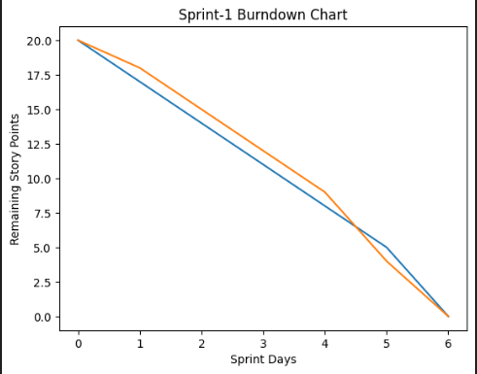

A Burndown Chart represents the remaining work against time.
- X-axis → Sprint Days
- Y-axis → Remaining Story Points
- The ideal line shows expected progress
- The actual line shows real progress
If the actual line stays close to the ideal line, the sprint is on track.
If it goes above, the team is behind schedule.
If it goes below, the team is ahead of schedule.

